ASSIGNMENTS

1. **LINKEDIN PROFILE**

URL: <https://www.linkedin.com/in/priyanka-m-30b948288?utm_source=share&utm_campaign=share_via&utm_content=profile&utm_medium=android_app>

1. **BRAND LOGO AND BRAND NAME PROMOTION ON FACEBOOK**

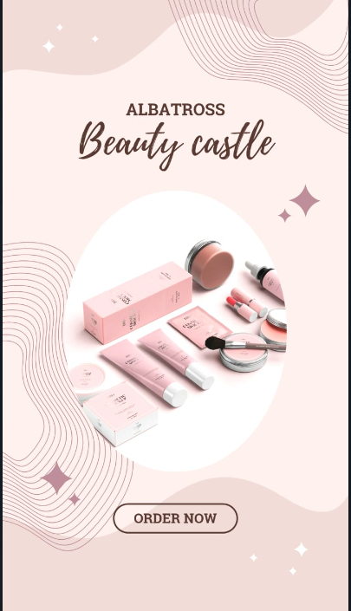

BRAND LOGO

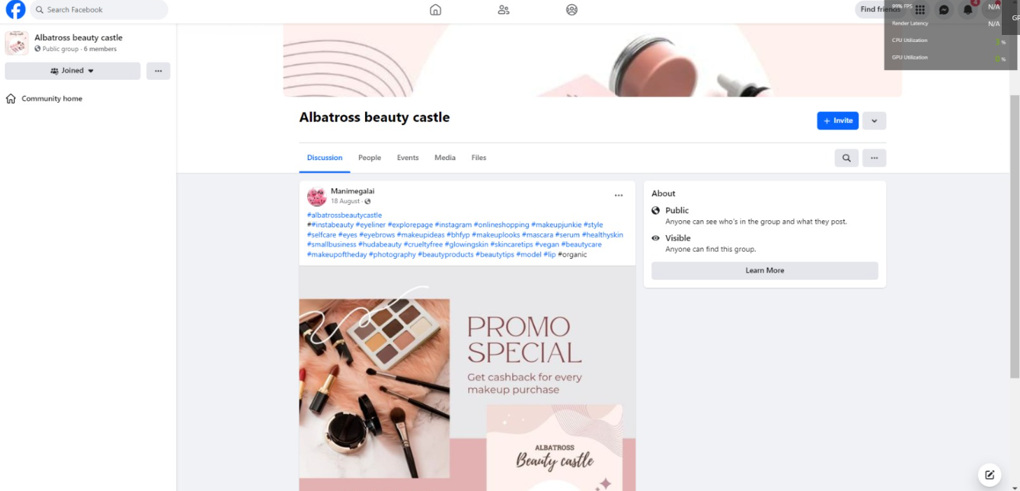

BRAND NAME PROMOTION ON FACEBOOK

1. **BLOGGER WEBSITE**

URL: <https://akshupriya.blogspot.com/?m=1>

1. **EMAIL NEWSLETTER**

**URL: <https://akshupriya.blogspot.com/2023/09/email-news-letter-priya-market.html?m=1>**

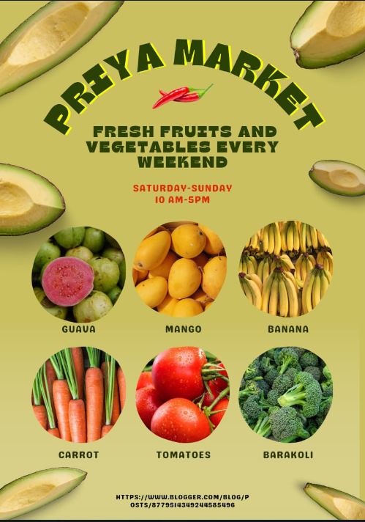

1. **INFOGRAPHICS**

URL : <https://akshupriya.blogspot.com/2023/09/infographic-travel-suggestions.html?m=1>

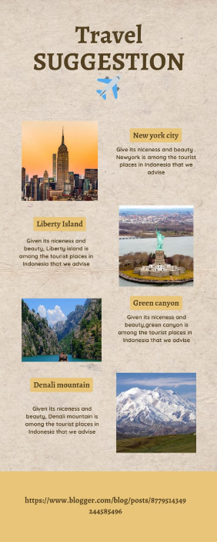

1. ARTICLE

URL: <https://akshupriya.blogspot.com/2023/10/articles-travel.html?m=1>

